Zach Tzavelis

ME465 - Sound and Space

02/28/2020

HW4: Spectrogram and Pulse Noise Revisited

**Spectrogram Analysis**

The purpose of the assignment was to analyze a time domain signal of a formula one car as it passes by a microphone. A spectrogram was created which shows how the power spectral density changes over time (Figure 1). The colors represent the amplitude of the power spectral density in decibels.

Figure 1: Spectrogram of a Formula One Car (Overlap: 25%, Number of Intervals: 300)

**Amplitude (dB re: 1 WU^2/Hz)**

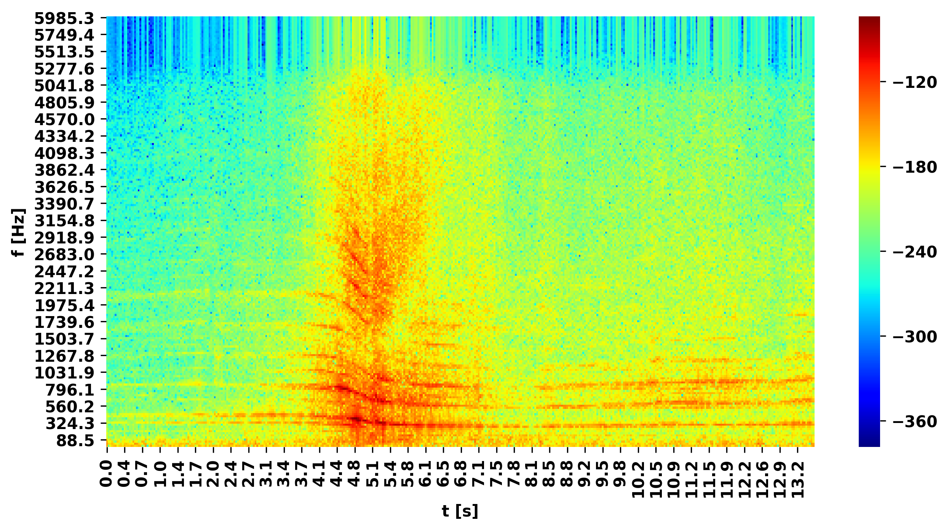

Below ~2000 Hz there are a series of curves which span the total length of the signal — these are the car’s harmonics. The reason that they change over time is due to the fact that the car is initially traveling toward the microphone, and then away, causing a change in perceived frequency at the microphone — this is called the Doppler effect. Although the car’s emitted frequencies are constant in its inertia frame, as the car moves toward the microphone the velocity of the car and the waves ‘add’ as more waves pass the microphone per second than they do as the car drives a way. Fewer waves hit the source per second as it drives away because the wave hitting the microphone and the car are traveling in opposite directions. Zooming into the spectrogram (Figure 1a) at the harmonic starting at 442 Hz (${(f}_{h}$), one can see it is most intense at 295 Hz ( $f_{0})$ when it is right in front of the microphone and assumed to see no relative velocity, and then turns to 383 Hz ${(f}_{l})$ afterward; using this information we can use Equation 1 to calculate the velocity that the car is traveling at — in this case its 70.6 m/s or about 157 mph, which seems reasonable for a race car.

Equation 1: $v = c\frac{{(f}_{h}-f_{l})}{{(f}_{0})}$

Figure 1a: Zoomed-in Spectrogram

**Amplitude (dB re: 1 WU^2/Hz)**

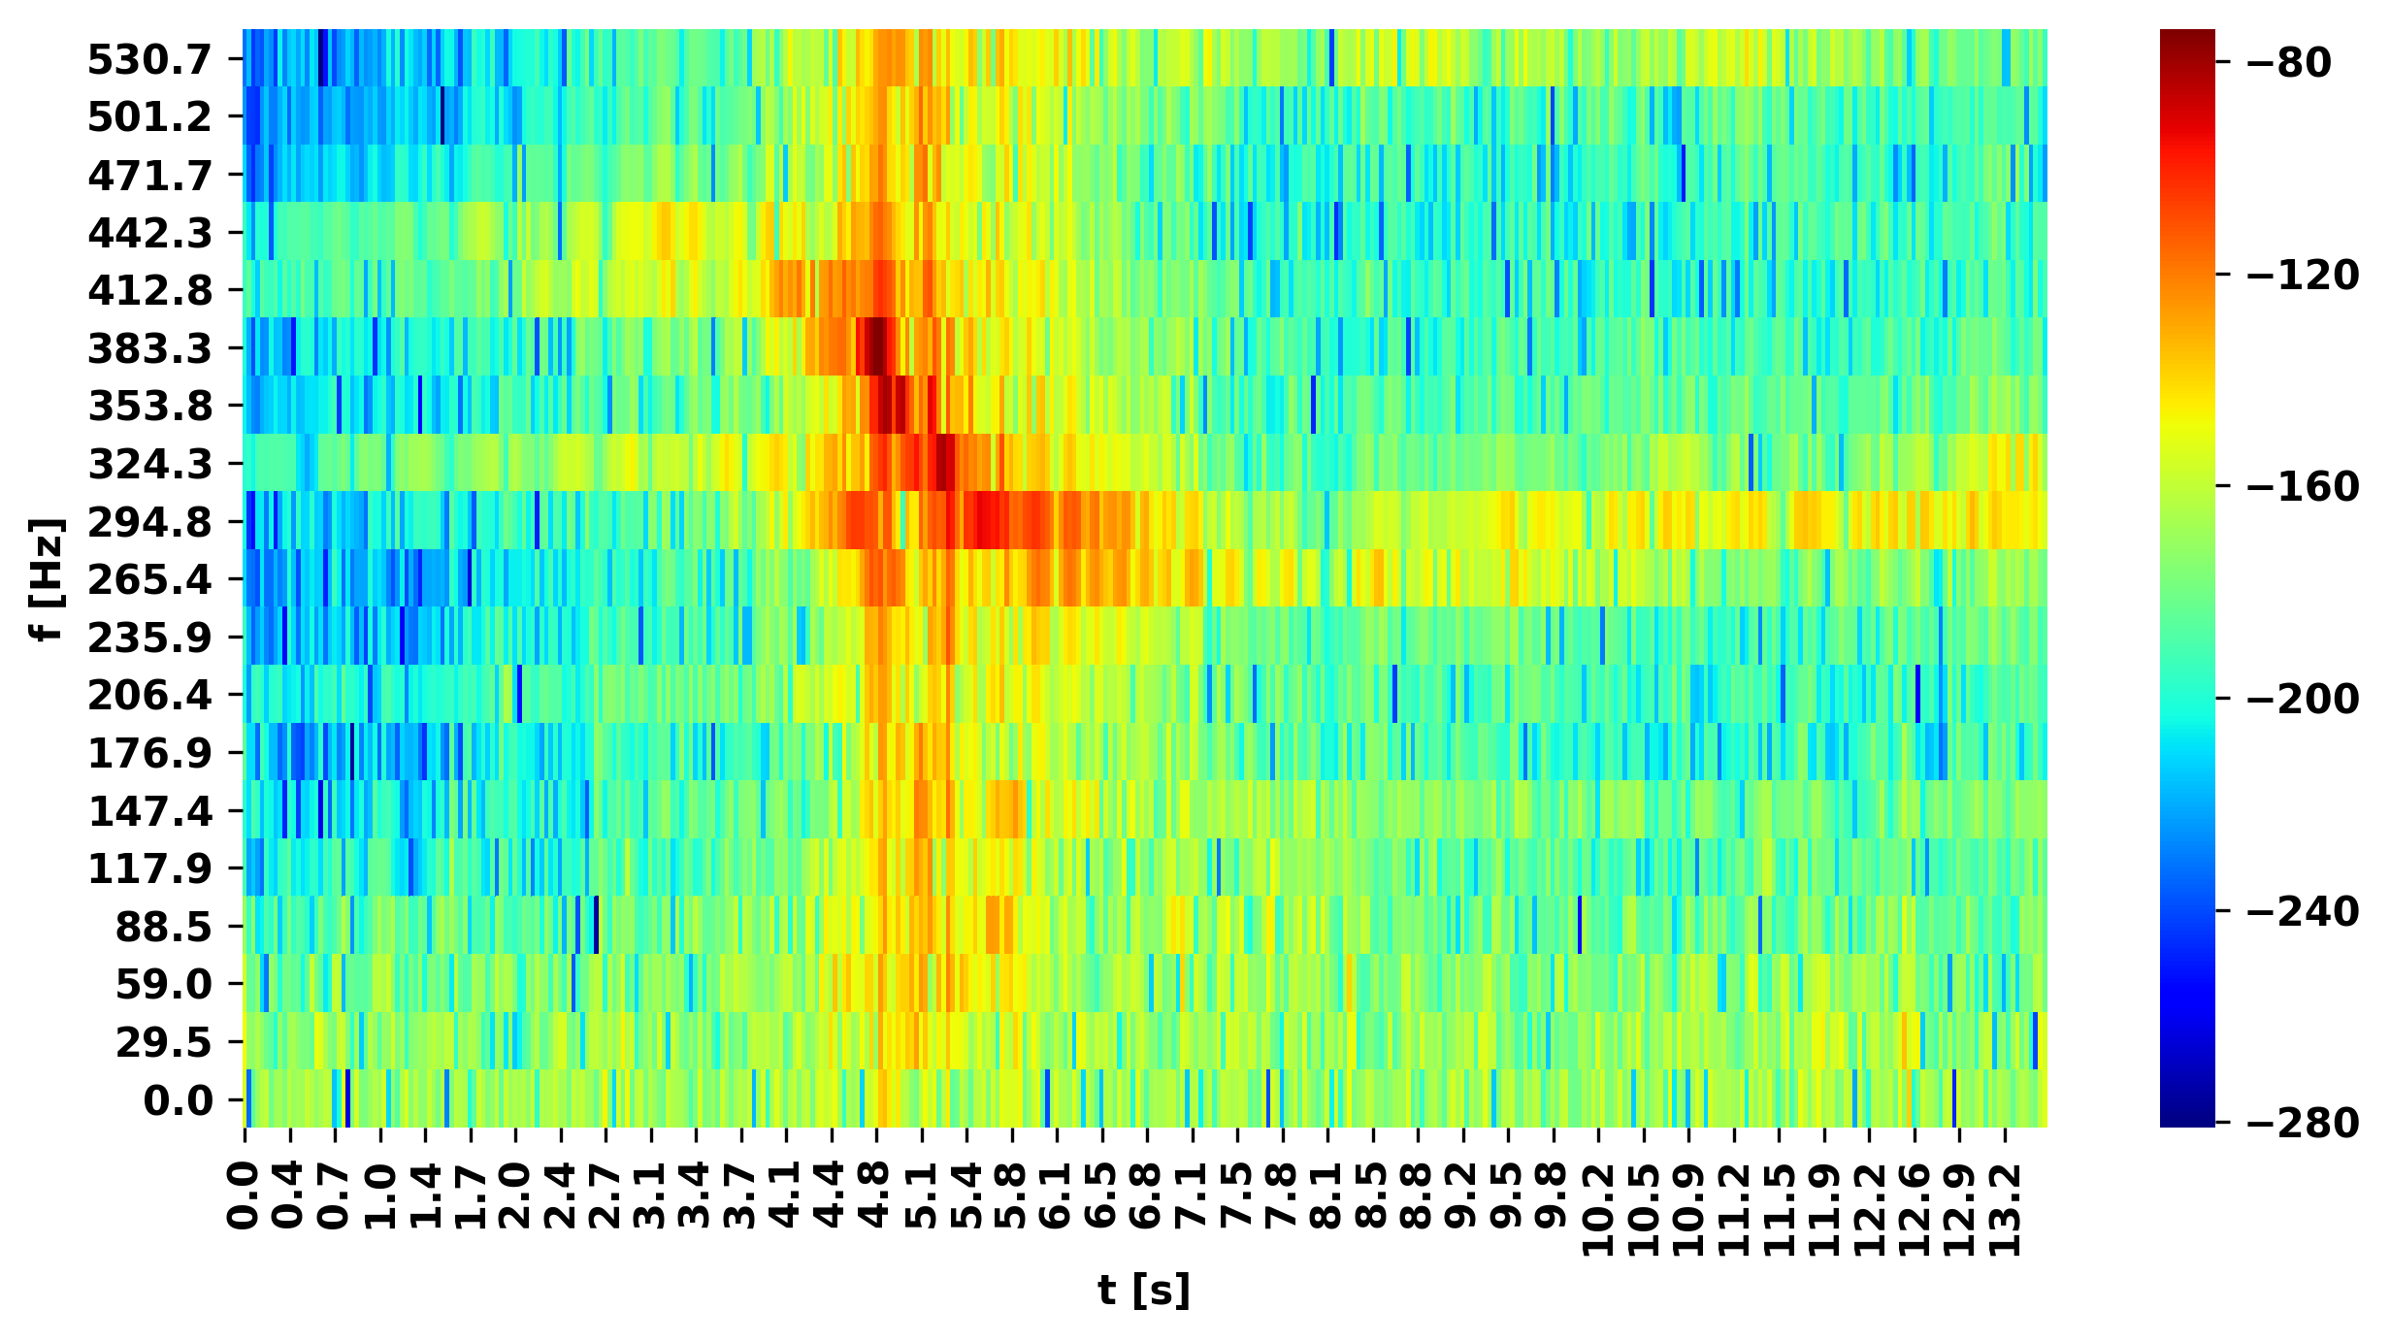

**Pulse in Noise Revisited**

The purpose of Part B in this exercise was to learn how to use auto-correlation to discover properties about a wave such as the amount of times it has a repeating underlying signal (and its length). Figure 2 shows the entire auto-correlation of the ‘signal in noise’; it can be seen that there is a single large peak in the middle and smaller ones spanning the length of time. The single largest peak corresponds with when there is no shift between the two signals, and we expect there to be a large amplitude here because the signals completely overlap.

Figure 2: Auto-correlation of Signal In Noise

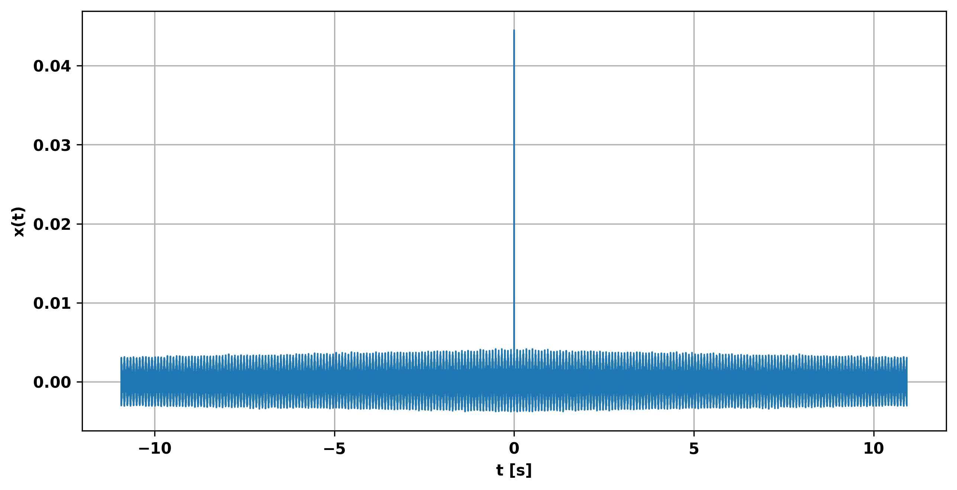

Figure 3 shows a zoomed view of Figure 2 in order to show the 256 smaller peaks (not counting the large one at t=0) each of which are of length: 0.069 seconds. These smaller peaks correspond to when a part of the repeating signal aligns with another one that is not at the same time step, causing a large amplitude to show up in the auto-correlation.

Figure 3: Zoomed In Auto-correlation of Signal In Noise

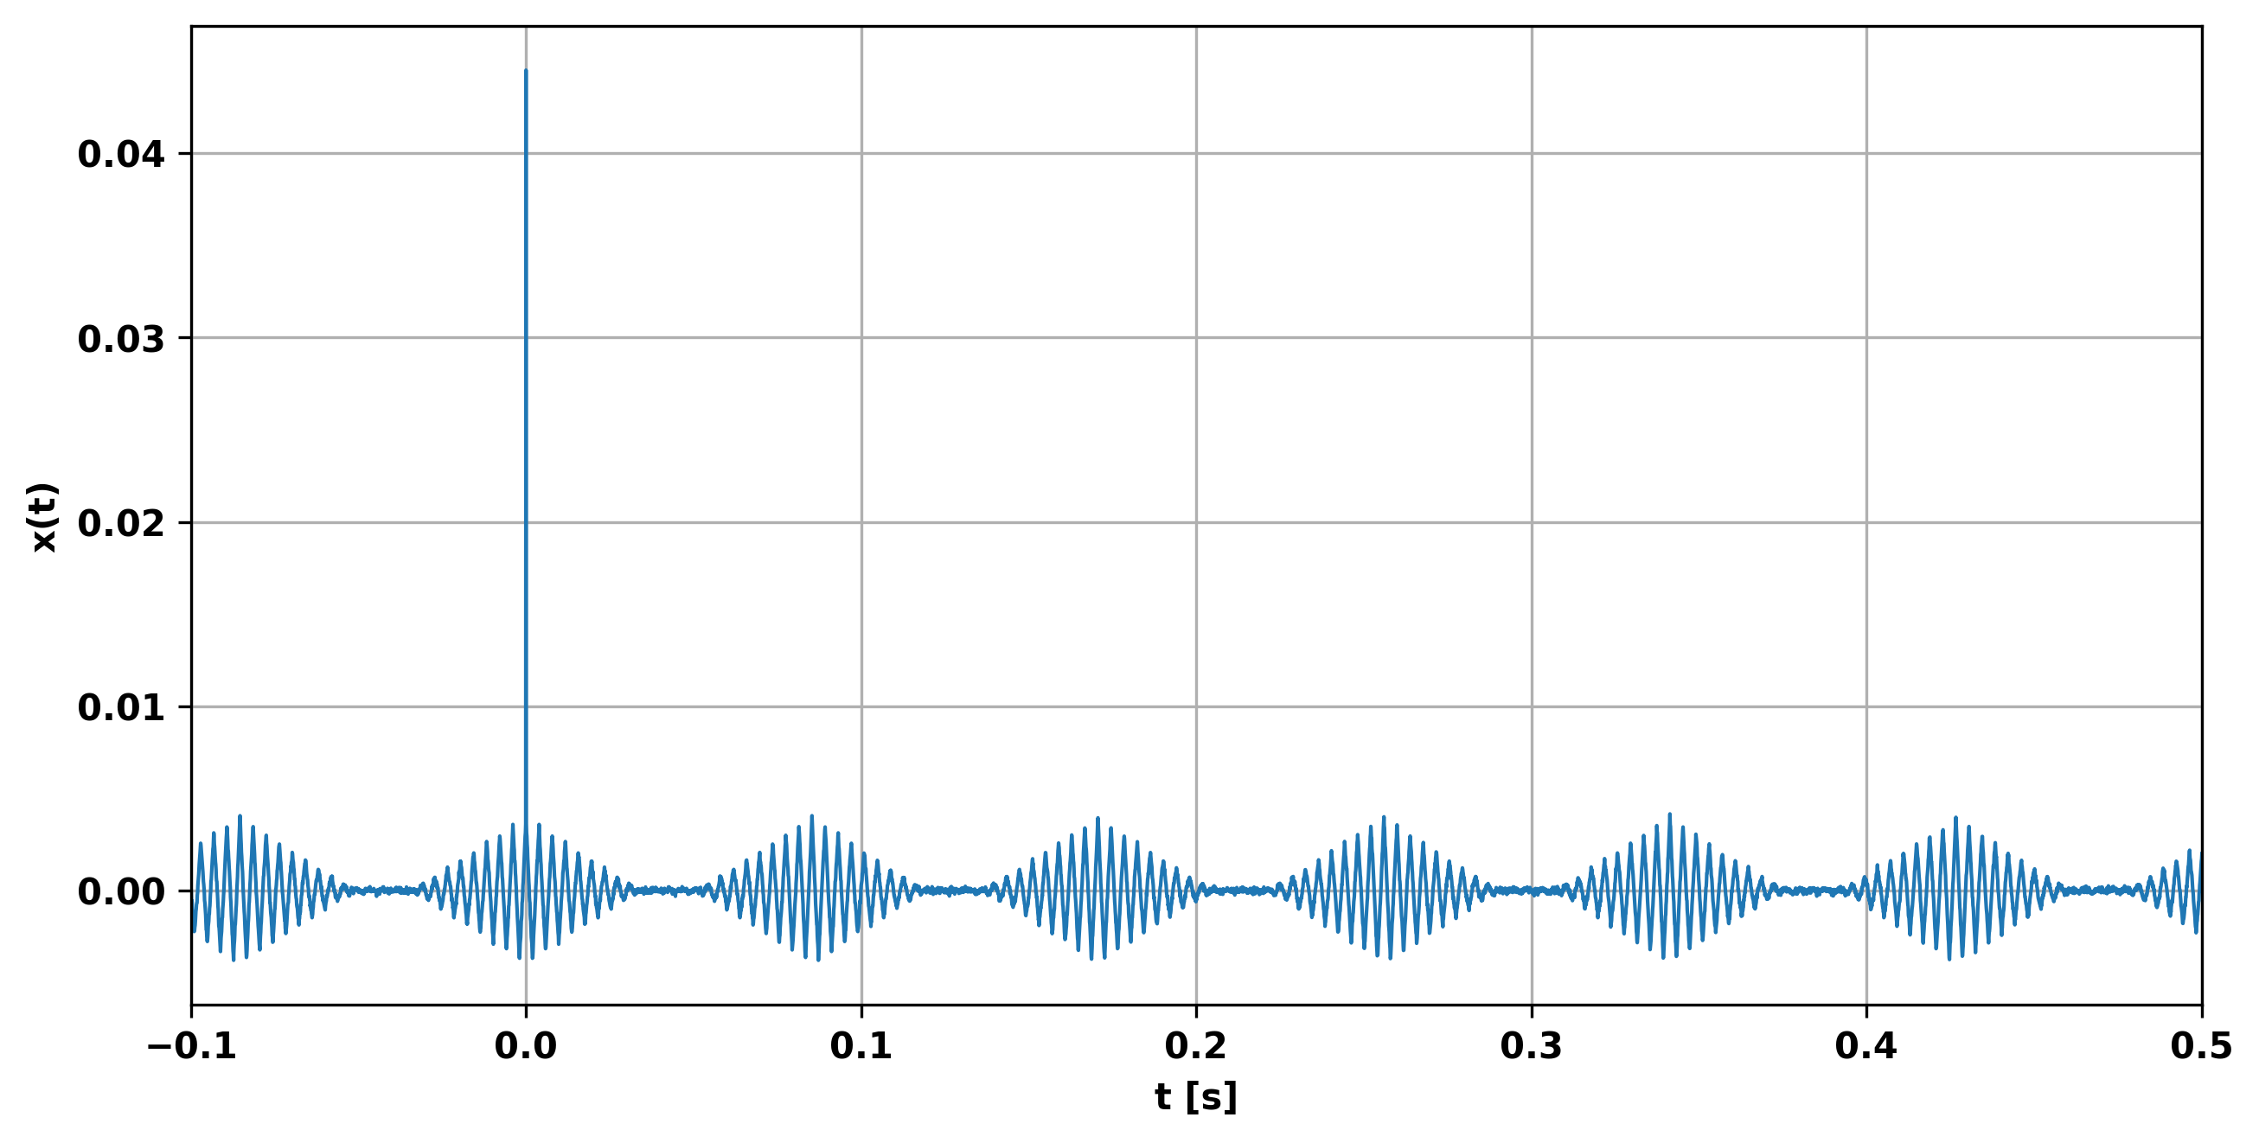

Part D of the assignment asked to study the cross-cross correlation between the source signal (with no noise) and the microphone signal (signal in noise) . To accomplish this, the first 1024 samples of the signal in noise signal was taken and cross-correlated with the source signal. Figure 4 shows the results from the cross correlation, which revealed a peak at delay of 0.0037 seconds; the delay represents the time the signal took to travel from the source to the microphone. Consequently, since the speed of sound is 343 m/s, the distance between the source and microphone is 1.28 m (343 * 0.0037)

**Figure 4: Cross Correlation of Pulse with Pulse Noise**

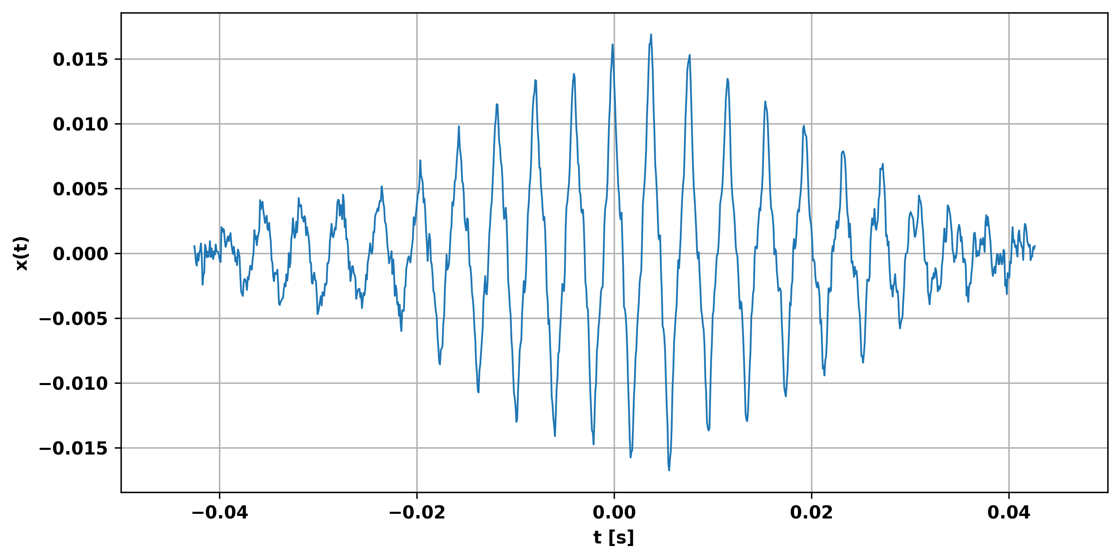

**Concluding Remarks**

The first major take away of this assignment is that the relative motion between two objects can cause a perceived change in frequency - known as the Doppler Effect. The second major take away is that you can use auto-correlation to find out information (number and length of hidden signal) about a repeating signal within a larger signal. The third take away is that you can use cross correlation between a source signal and microphone signal to find the distance between the two objects.